**Global Supply Chain Networks: Risk Assessment and Emergency Response Tool**

Project Lead: Dr. Kayvan Miri Lavassani, North Carolina Central University, School of Business

Partners: Dr. Zachary M. Boyd UNC-Chapel Hill, Department of Mathematics

**Summary:** NCCU’s School of Business has the capability to access, mine and analyze big data related to the multi-tier supply chain of every industry on a global scale. The investigator has the capability to design complex network models, detect global supply chain vulnerability and provide alternative solutions using network analytics algorithms to provide fast emergency response. Over the past few weeks, the investigator has started a large scale project which is presented in this document as the proof of concept. Examples of the past works, as well as work-in-progress on the 10-tier global supply chain of medical equipment is presented in this document (5 tiers forward supply chain, and 5 tiers backward supply chain). An example is also provided where the model designed by the investigator, correctly predicted the alternative to the disrupted global supply chain of Medical Equipment as a result of COVID19. On March 27, 2020 “President Trump ordered General Motors Co. to … ramp up the production of ventilators”[1]. Our model correctly suggested that “Motor vehicles and car bodies” industry is the only industry that can replace such rupture in the global supply chain network of medical equipment (see Figure 3). Our model is also capable of detecting risk exposures in the supply chain. Using network analytics techniques our model is capable of providing a fast emergency response (e.g. alternative supply chain route) to global supply chain ruptures at the firm level, multinational firms’ cluster level, and the country level. The project has immediate application for businesses, investors, health care providers, disaster responders, areas affected by natural disasters and wars as well as policymakers who are concerned with global supply chain vulnerability of the United States, particularly as it relates to essential goods and services.

**Introduction**

Over the past half a century, the world has experienced a significant increase in global integration at the country, industry, firm and individual levels. Thanks to advancements in communication and computing technologies of the recent decades, we have experienced significant transformation in the ways global and regional collaborations take place. In specific sectors, a competition that was traditionally among the businesses and their supply chains has turned into a competition among the business ecosystems. These ecosystems include multi-layer networks of people, firms, universities, industries, and countries. The leading players in the global ecosystems not only compete with each other but also they are engaged in significant cooperation and collaboration –known as coopetition. The business ecosystem includes multi-layer interactions among individual actors, for-profit and nonprofit organizations, industries, as well as nations.

In light of the COVID19, the world realized the risk of depending on such inter-connected global networks. In many cases, several countries failed to respond effectively and efficiently to restore the supply of critical products and services. In this proposal, we offer a unique approach to identify the global supply chain of products and services using mined data. Additionally, we provide solutions to identify the risk of each firm/industry/county and how to react in case of a disruption in any firm, industry, and country. In this proposal, we have illustrated our preliminary work on the global networks of “Medical, Dental, and Hospital Equipment and Supplies” (SIC 5047). The illustrations presented in this statement are the very early result of our 10 tier analysis of millions of global supply chain connections.

In the following, a discussion of the evolution of studies on business ecosystems from the study of biological systems to business ecosystems and platforms ispresented. Following the description of the proposed multi-layer business ecosystem and the past feasibility studies of single-layer networks, a discussion of data collection and data analysis are presented. Finally, the implications of the findings for different stakeholders, as well as the venues of disseminating the results of this study are described.

**Multi-Layer Networks of Business Ecosystem**

The business ecosystem should be investigated through multi-layer analysis of the ecosystem at the country, industry, firm, and individual levels. Figure 1 displays different levels of analysis, which are feasible currently to be employed in the study of business ecosystems.

Figure 1: Multi-layer analysis of business ecosystems: Layers of business ecosystem sphere

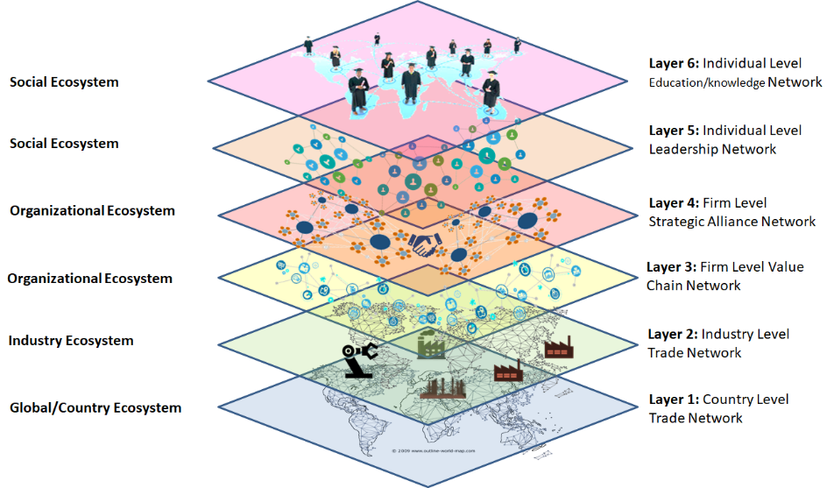

The author of this document has conducted feasibility studies on all layers of the business ecosystem within select industries. While the main goal of this study is to analyze the industry-specific global supply chains we do have capabilities to develop and analyze such networks at all of the six outlined levels. Figure 2 displays a single layer visualization of each of the six (6) layers of the business ecosystem.

Figure 2: Single-Layer Business Networks Feasibility Study: Limited to one industry[2]

|  |  |  |
| --- | --- | --- |
| **Layer 1**  Global Trade  https://www.researchgate.net/profile/Kayvan_Miri-Lavassani/publication/326235033/figure/fig1/AS:645481231310848@1530906126514/figure-fig1.png | **Layer 2**  Global Trade | **Layer 3**  Pharma Industry Value/Supply Chain |
| **Layer 4**  Auto Industry Strategic Alliance | **Layer 5**  Pharma Industry Boards of Directors (BOD) | **Layer 6**  Pharma Industry BOD education: Knowledge Network of Alma Mater |

The pioneers of network analytic techniques promoted a "shift away from methodological individualism to structural analysis" (Wellman, 1983, p. 170). This network view is the foundation of modern business models which are actively operating within business ecosystems. Recent studies (c.f. Lu et al. 2018) have described potential innovative analytical solutions to the study of complex multilayer networks and have discussed the feasibility of exploring structures across several levels of analysis.

**Data Collection & Data Analysis**

One of the critical aspects of proposing an ambitious project (similar to the current proposal) is proof of concept. The author's ability to mine and prepare the data, as well as the analytical capabilities, are demonstrated in Figure 2. Visualizations presented in Figure 2 are conducted by the author of this proposal and are testimonies to the ability to undertake such projects. In this section, a discussion on data collection and data analysis is presented to highlight the capability of collecting required data at each layer and analyzing such complex models. The analysis conducted so far has been mostly focused on centrality analysis and clustering analysis. Since this proposal is aiming to study multi-layer networks it is expected that the author faces new theoretical and analytical challenges. For example, one challenge in conducting multi-layer analysis is that these layers together construct the business ecosystem, and in creating such multi-layer structures "conflict may exist between networks at different layers" (Lu et al., 2018). Due to the complexity of such models if the structural pattern recognition of the ecosystem is not accurate the researchers may "obtain [a] worse result" (Lu et al., 2018). This study will utilize various machine learning and network analysis techniques to uncover and explore changes in business ecosystem patterns (c.f. Wieringa et al. 2019).

**COVID19 and Global Supply Chain of Medical Equipment**

In light of the significant global effect of COVID19 on the availability of medical equipment, NCCU started to develop a multi-tier network of the global supply chain of “Medical, Dental, and Hospital Equipment and Supplies” (SIC 5047). While this is a work in progress activity at its early stages some visualizations are presented here to outline the capability of NCCU as well as the application of the network analysis in detecting as well as responding to emergency events.

Medical Equipment Supply Chain Industry Level & Firm Level (Should this be a heading?)

One level of analysis is exploring the various industries around the world that contribute to the manufacturing of medical equipment. One of the problems facing the global supply chains is to identify the consequence of the absence of a country in the global supply chain. Figure 3 illustrates the consequence of eliminating China from the global supply chain of medical equipment.

Figure 3: 2020 Medical Equipment Supply Chain Industries: With and Without China

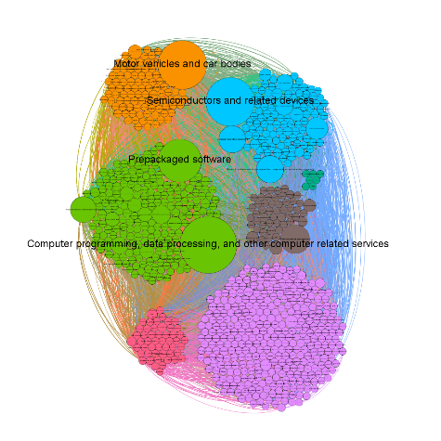 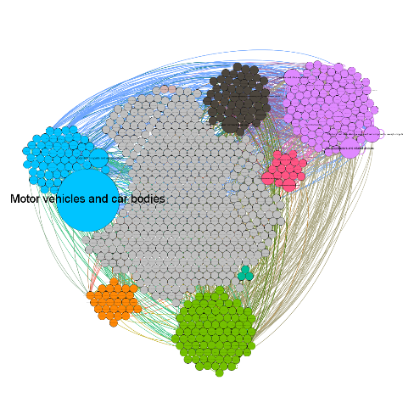

All countries All countries except China

The graph on the left (Figure 3) illustrates the global supply chain of medical equipment with the participation of all countries. The graph on the right identifies how the global supply chain changes when we eliminate China. The result illustrates that in situations where all companies from a particular country (in this case China) are omitted from the global supply chain, the “Motor vehicles and car bodies” industry becomes the most central to the global supply of medical equipment. This analysis includes five (5) tier backward supply chains of global medical equipment network. Currently, we are investigating the forward tiers of the global supply chain.

Furthermore, we also have the capability to investigate such networks at the country level at the individual firm level. Figure 4 illustrates the multi-tier supply chain of the medical equipment supply chain at the firm level.

Figure 4: 2020 Medical Equipment Supply Chain Companies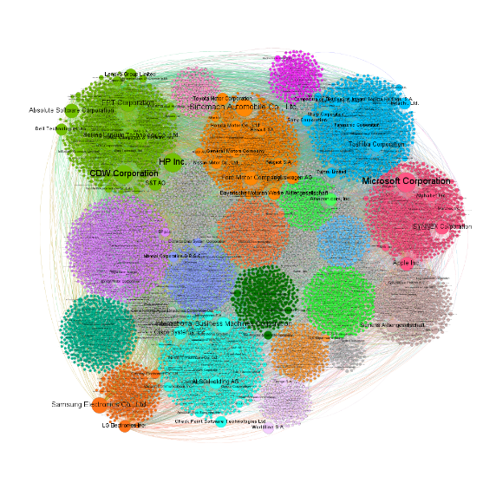

In the above visualization, each circle represents a firm across the 5-tier backward global network of the medical equipment industry. The size of the node represents the influence of each firm (as measured by eigenvector centrality) while the colors represent clusters of firms closely work together.

**Implications of the findings**

This project has enormous value for various stakeholders including academics, policymakers, and professionals in profit and nonprofit organizations. The significance of this work is highlighted by its novelty, use of unique big data and wide applications. In the following, some of the main implications are discussed.

*Implications for Global Emergency Response*: While policymakersas described in the followingcan use the global supply chain network to modify future global policies, the proposed tool has immediate application to detect risk factors of the global supply chain, and provide effective emergency response. For example, our work-in-progress analysis (see Figure 3) recommended that if there is an interruption of the supply chain from China, the “Motor vehicle and Car Bodies” sector will be a replacement of the supply chain for medical equipment from China. Our model is powerful enough to provide an immediate response. However, in the case of COVID19, as we observed in the United States, it took the country several months to figure out that US car manufacturers are the replacement for the ruptured supply chain of the medical equipment.

*Implications for Policy Makers:* Policymakers working on **global connection** can utilize the outcome of this research to explore the consequences of local and global policies on trade patterns, organizational performance as well as individuals’ movements. Another implication of this study for policymakers is that it provides a powerful tool to launch or combat the **global ruptures,** including trade wars, pandemics and natural disasters stemming from natural events (e.g. climate change) and human-made events (e.g. wars, supply-chain interruptions, sanctions). For example, using our findings, corporate strategists and policymakers can design **high-accuracy** offensive and defensive strategies during the **disasters**, **pandemic**, **trade-wars** and **counter-terrorism** events, not only at the country level and industry level but also at the firm level and individual level. Changes in business ecosystem patterns can help national, regional and local agencies to explain and plan for the trends in global and regional and better manage inequality in wealth distribution and employment.

*Implications for Business Strategies:* This project will enable to better manage the risk and interruptions across their global value chain and uncover the most influential actors affecting their global operations. The findings can be extended to provide benchmarks for assessing the role of network centrality of individuals on compensation.

*Implications for Technology Management and Knowledge Dissemination:* This research enables businesses and policymakers to more effectively identify the innovation hubs across at a global scale using big data (c.f. Aksenova et al. 2019). The result of this study can be further expanded to uncover patterns of knowledge and the impact of technology that crosses industries and borders.

**Dissemination of the Project Output.** The result of this project will be disseminated through professional/academic publications as well as an interactive website similar to MIT DataUSA, but for the global supply chain network as described.

**References**

Aksenova G., Kiviniemi A., Kocaturk T., and Lejeune A. (2019) From Finnish AEC knowledge ecosystem to business ecosystem: lessons learned from the national deployment of BIM. Construction Management and Economics, 37(6), pp. 317-335.

Lu J., Xuan J., Zhang G. and Luo X. (2018). Structural property-aware multilayer network embedding for latent factor analysis, Pattern Recognition, 76, pp. 228-241.

Wieringa, R..J., Engelsman W., Gordijin J., Ionita D. (2019). A Business Ecosystem Architecture Modeling Framework, Proceedings of 2019 IEEE 21st Conference on Business Informatics (CBI), July 15-17, 2019, Moscow, Russia.

1. Wall Street Journal, Trump Orders General Motors to Make Ventilators, March 27, 2020.
2. Except for layers 1 & 2, the other networks are currently limited to one industry. Node sizes represent eigenvector centrality. Node colors represent cluster membership.